**Highly Contiguous Genome Assembly of *Drosophila prolongata* - a Research Model for Evolution of Sexual Dimorphism and Male-specific Innovations**

**Introduction**

*Drosophila prolongata* is a member of the *melanogaster* species group and *rhopaloa* subgroup native to southeast Asia (Singh & Gupta, 1977; Toda, 1991). The species has a suite of recently evolved male-specific morphological traits (Fig. 1), including relative foreleg size, leg pigmentation, wing pigmentation, reversed size sex dimorphism, and an expanded number of leg chemosensory organs (D. Luecke et al., 2022; D. M. Luecke & Kopp, 2019; Luo et al., 2019). These traits are associated with derived behaviors, including male-male grappling and male leg vibration courtship displays, along with divergence in sex-specific cuticular hydrocarbon profiles (Kudo et al., 2017; Luo et al., 2019; Setoguchi et al., 2014).

The phylogenetic proximity to the model *D. melanogaster* and available genome sequences for underived sister species *D. rhopaloa* and *D. carrolli* (Kim et al., 2021) make this species a promising system to study the genetics of dimorphic development, physiology, and behavior (Barmina & Kopp, 2007). A reference genome assembly and annotation for *D. prolongata* will benefit such work. Presented here is a highly complete and contiguous assembly generated by Dovetail Genomics (Cantata Bio. LLC, dovetailgenomics.com) based on long-read PacBio sequencing and Hi-C scaffolding, along with annotations for both *D. prolongata* and *D. carrolli* using *D. melanogaster* sequence homology and gene models based on RNA sequencing evidence and *ab initio* predictions.

**Materials and Methods**

Genome line generation

The isofemale SaPa01 line was collected in Vietnam by Dr. Hisaki Takamori. Virgin females were collected by isolating adults within four hours of emergence. Four generations of full sibling matings were carried out to produce the genomic strain SaPa_ori_Rep25-2-1-1 (“Sapa_PacBio”). Fly strains were maintained at room temperature on standard cornmeal food provided by the UC Davis Fly Kitchen with filter paper for environment structure and pupariation substrate.

Tissue collection

For genome assembly/scaffolding, adult male flies from the genome strain were moved onto plain agar food for at least one day to reduce gut microbes, then collected into 1.5mL tubes and flash-frozen in liquid nitrogen. 50 frozen adult male individuals were sent on dry ice to Dovetail Genomics for DNA extraction, sequencing, and assembly. For gene expression data used in annotation, whole forelegs were dissected from carbon dioxide anesthetized males and females of the SaPa01 isofemale line, along with dissected heads from each sex of the genome strain.

Sequencing and assembly

All genomic DNA extraction, sequencing, and assembly were carried out by Dovetail Genomics (Cantata Bio LLC, Scotts Valey, CA, USA). Genomic DNA was extracted with the Qiagen HMW genomic extraction kit (Qiagen, Germantown, MD, USA). DNA samples were quantified using Qubit 2.0 Fluorometer (Life Technologies, Carlsbad, CA, USA). The PacBio SMRTbell library (~20kb) for PacBio Sequel was constructed using SMRTbell Express Template Prep Kit 2.0 (PacBio, Menlo Park, CA, USA) using the manufacturer-recommended protocol. The library was bound to polymerase using the Sequel II Binding Kit 2.0 (PacBio) and loaded onto PacBio Sequel II. Sequencing was performed on PacBio Sequel II 8M SMRT cells generating 16 gigabases of data. An initial assembly based on 1.2M PacBio reads was produced using FALCON (Chin et al., 2016) with Arrow polishing.

A Dovetail HiC library was prepared similarly as described previously (Lieberman-Aiden et al., 2009). Briefly, for each library, chromatin was fixed in place with formaldehyde in the nucleus and then extracted. Fixed chromatin was digested with DpnII, the 5’ overhangs filled in with biotinylated nucleotides, and free blunt ends were ligated subsequently. After ligation, crosslinks were reversed, and the DNA was purified from protein. Purified DNA was treated to remove biotin that was not internal to ligated fragments. The DNA was then sheared to ~350 bp mean fragment size, and sequencing libraries were generated using NEBNext Ultra enzymes and Illumina-compatible adapters. Biotin-containing fragments were isolated using streptavidin beads before PCR enrichment of each library. The libraries were sequenced on an Illumina HiSeq X to a target depth of 30x coverage.

The input *de novo* assembly and Dovetail HiC library reads were used as input data for HiRise, a software pipeline designed specifically for using proximity ligation data to scaffold genome assemblies (Putnam et al., 2016). Dovetail HiC library sequences were aligned to the draft input assembly using a modified SNAP read mapper (http://snap.cs.berkeley.edu). The separations of Dovetail HiC read pairs mapped within draft scaffolds were analyzed by HiRise to produce a likelihood model for genomic distance between read pairs, and the model was used to identify and break putative misjoins, to score prospective joins, and make joins above a threshold. A second HiRise assembly was generated with additional HiC sequencing and the HiRise software pipeline.

RNA was extracted using TRIzol (Invitrogen, Waltham, MA, USA). For foreleg RNA, multiplexed stranded cDNA sequencing libraries were prepared using the NEBNext Ultra Directional RNA Library Prep Kit for Illumina (New England BioLabs, Ipswich, MA, USA) using poly(A) isolation magnetic beads. Libraries were sequenced on the Illumina HiSeq4000 platform by the UC Davis Genomics Center. For head RNA, cDNA sequencing libraries were constructed using the TruSeq Stranded RNA Kit (Illumina, San Diego, CA) and sequenced on the Illumina HiSeq4000 platform by Novogene (https://www.novogene.com/us-en/). Transcripts were assembled using Trinity 2.4.0 (Haas et al., 2013) with default options for stranded data.

Gene prediction and annotation

Homology-based annotations were generated using Liftoff 1.5.1 (Shumate & Salzberg, 2021) with minimap2 2.17 (Li, 2018) alignment based on the *D. melanogaster* GCF000001215.4 release 6 (Hoskins et al., 2015), *D. elegans* GCF000224195.1 2.0, and *D. rhopaloa* GCF000236305.1 2.0 (Kim et al., 2021) annotations downloaded from FlyBase (Gramates et al., 2022). Liftoff was run with the copies option and percent identity 0.80. Additional gene models were inferred using MAKER 3.01.02 (Holt & Yandell, 2011) with BLAST 2.11.0 (Camacho et al., 2009) and repeat masker 4.0.7, using EST evidence from the Trinity transcripts assembled based on leg RNA and protein homology evidence based on the combined protein sets from the *D. melanogaster* and *D. elegans* annotations also used for Liftoff. The annotations from different sources were then combined using gffcompare 10.4 (Pertea & Pertea, 2020), genometools 1.5.9 (Gremme et al., 2013), and custom Python scripts available at <https://github.com/dluecke/annotation_tools>.

Removal of duplicate scaffolds

BUSCO (Manni et al., 2021) analysis of the Dovetail HiRise using the diptera_ocb10 lineage dataset included 200 complete but duplicated benchmark genes (Supplemental Table 1), indicating potential duplicated regions in the assembly. Scaffolds were assessed for BUSCO benchmark gene content and sorted by percent duplicated, providing 34 candidate duplicate scaffolds containing only duplicated benchmark BUSCO genes (Supplemental Table 1). Inspection of MUMmer (Marçais et al., 2018) alignments between duplicate candidates and sister scaffolds (scaffolds with alternate copies of duplicated benchmark gene) show complete alignment across 27 of the candidates (Fig. S1). These 27 scaffolds were considered fully duplicated and split from the assembly and annotation (Supplemental files 1, 2 and 3) using SAMtools 1.15.1 (Li et al., 2009). Custom scripts for scaffold sorting by BUSCO scores and splitting assembly and annotation are available at <https://github.com/dluecke/annotation_tools>.

Repeat analysis

Tandem repeats were annotated with Tandem Repeat Finder 4.09.1 (Benson, 1999). A de novo library of classified repetitive element models was created using RepeatModeler 2.0 (Flynn et al., 2020). To reduce the run-to-run variations, repeat classification was based on five independent RepeatModeler runs with the following random seeds: 1681089287, 1687990919, 1683413925, 1683532158, and 1683532058. Custom R and Bash scripts are available at <https://github.com/yige-luo/Repeat_analysis>.

Assembly and annotation evaluation

Assembly contiguity statistics were provided by Dovetail. Reference annotations *D. melanogaster* GCF_000001215.4 and *D. rhopaloa* GCF_018152115.1 were downloaded from the NCBI genomes database. Assembly completeness was assessed with BUSCO 5.3.2 (Manni et al., 2021) using the diptera_ocb10 lineage dataset, HMMER 3.1b2, and Mmseqs 5.34c21f2. Whole genome alignment between *D. prolongata* and *D. rhopaloa* assemblies was performed with MUMmer 4.0.0 (Marçais et al., 2018) using nucmer alignment with a minimum exact match 1000bp for alignment with *D. rhopaloa* and 500bp for *D. melanogaster* alignment,and mummerplot for visualization. Annotation statistics were found with genometools 1.5.9 (Gremme et al., 2013). Transcripts were extracted from annotations using gffread 0.9.12 (Pertea & Pertea, 2020), and transcript completeness was assessed using the transcriptome mode of BUSCO.

**Results and Discussion**

Assembly contiguity

The Dovetail HiRise assembly scaffolding method (Fig. 2) produced an assembly for *D. prolongata* with higher contiguity than the existing *D. rhopaloa* assembly, approaching the contiguity of the latest *D. melanogaster* reference (Table 1) as measured by N50 or N90. Whole genome alignments between the *D. prolongata* assembly and *D. rhopaloa* and *D. melanogaster* references (Fig. 3A) show long stretches of high identity with *D. rhopaloa* spanning nearly all large scaffolds.

|  |  |  |  |  |
| --- | --- | --- | --- | --- |
| **Assembly** | *D. prolongata* | *D. carrolli* | *D. rhopaloa* | *D. melanogaster* |
| **Total length (bp)** | 220759777 | 231219246 | 193508231 | 143726002 |
| **Scaffolds** | 387 | 338 | 228 | 1870 |
| **N50 (bp)** | 22190323 | 14004682 | 15806012 | 25286936 |
| **L50** | 4 | 5 | 5 | 3 |
| **GC%** | 40.11% | 39.52% | 39.87% | 41.67% |
| **BUSCO Complete, Single Copy** | 93.7% (3078) | 97.8% (3214) | 98.1% (3221) | 98.5% (3235) |
| **BUSCO Complete, Duplicated** | 4.8% (158) | 0.4% (13) | 0.4% (12) | 0.2% (8) |
| **BUSCO Fragmented** | 0.9% (29) | 0.6% (19) | 0.7% (24) | 0.5% (16) |
| **BUSCO Missing** | 0.6% (20) | 1.2% (39) | 0.8% (28) | 0.8% (26) |

Table 1: Statistics for assembly contiguity and completeness of *D. prolongata* assembly alongside previously published *D. carrolli* GCA_018152295.1 assembly (Kim et al., 2021), reference assemblies *D. rhopaloa* GCF_018152115.1 and *D. melanogaster* GCF_000001215.4. BUSCO statistics are for the 3285 genes in the diptera_odb10 benchmark set.

Assembly completeness

BUSCO results for assemblies (Table 1) show a comparable degree of completeness for the 3285 genes in the BUSCO dipteran benchmark set between *D. prolongata* assembly and references, with 3236 complete for *D. prolongata*, 3233 complete for *D. rhopaloa*, and 3243 complete for *D. melanogaster*. The whole genome alignments between the *D. prolongata* assembly and the *D. rhopaloa* (Fig. 3A) and *D. melanogaster* references (Fig. 3B) further show near complete highly contiguous coverage of the entire reference with regions of *D. prolongata* scaffolds, corresponding to all five major chromosome arms in the *D. melanogaster* genome.

Repeat annotation

The *D. prolongata* genome exhibits a moderate (24.6%) yet comparable level of repeat content as with other reference species (Fig. 4). Among the repetitive regions of *D. prolongata*, the most prominent repeat classes are Long Terminal Repeats retrotransposons (LTR, 32.2%), Long Interspersed Nuclear Element (LINE, 15.1%) and Tandem Repeats (14.6%, Table 2). A breakdown of repeat content by scaffolds across four species can be found in Supplemental Table 2.

Compared with most long (>1Mb) scaffolds, intermediate-sized scaffolds in *D. prolongata* assembly tend to show higher repeat content (Fig. S2, Fig. S3). Exceptions are found in scaffolds 414, scaffold 293, scaffold 164 and scaffold 280 (Fig. S2), where LTR and LINE are overrepresented, reminiscent of the repeat profiles of several primary scaffolds in closely related species D. carrolli and D. rhopaloa (Fig. S4, Fig. S5), as well as Y chromosome in *D. melanogaster* (Fig. S6).

|  |  |  |  |  |
| --- | --- | --- | --- | --- |
| **Repeat Class** | ***D. prolongata* (%)** | ***D. carrolli* (%)** | ***D. rhopaloa* (%)** | ***D. melanogaster* (%)** |
| Tandem Repeat | 3.627 | 12.003 | 6.601 | 2.421 |
| Simple | 0.008 | 0.007 | 0.008 | 0.007 |
| Satellite | 0.019 | 0.017 | 0.012 | 0.031 |
| DNA | 1.067 | 1.224 | 0.971 | 0.877 |
| RC | 1.595 | 1.122 | 1.274 | 0.218 |
| LINE | 3.727 | 3.626 | 3.612 | 3.526 |
| LTR | 7.939 | 7.505 | 6.141 | 8.525 |
| rRNA | 0.061 | 0.014 | 0.000 | 0.040 |
| snRNA | 0.000 | 0.001 | 0.004 | 0.000 |
| tRNA | 0.005 | 0.001 | 0.004 | 0.005 |
| Unknown | 3.276 | 2.686 | 2.519 | 0.575 |
| Multiclass | 3.311 | 3.926 | 3.260 | 1.896 |
| **Total** | **24.636** | **32.131** | **24.406** | **18.121** |

Table 2: Repeat content of genome assemblies of *D. prolongata* and three reference species.

Annotation completeness

Transcripts extracted from the annotation and assembly show a high degree of completeness for the *D. prolongata* and *D. carrolli* annotations. However, they do not match the completeness of the *D. rhopaloa* and especially *D. melanogaster* references (Table 3), both in terms of gene inclusion and completeness of individual gene models. A higher number of BUSCO dipteran benchmark genes are missing in the *D. prolongata* (95) and *D. carrolli* (115) annotationscompared to the *D. rhopaloa* (15) or *D. melanogaster* (0) references. Additionally, the transcripts in the *D. prolongata* and *D. carrolli* annotationsare shorter than those from the references, and many more BUSCO dipteran benchmark genes are fragmented in the *D. prolongata* (109) and *D. carrolli* (89) annotations than for the references (both 3). These statistics show the limitations of current algorithmic annotation methods and indicate that care should be used when using gene models from these draft annotations. Despite these limitations, the overall completeness is quite high, with 93.8% of BUSCO benchmark genes covered in both *D. prolongata* and *D. carrolli* annotations,and appropriate median transcript lengths in both. These resources will provide a good foundation for future genetic studies in *D. prolongata* and relatives when used with the limitations of draft annotations in mind, and future iterations of the annotations should aim to improve gene model coverage and completeness.

|  |  |  |  |  |
| --- | --- | --- | --- | --- |
| **Annotation** | *D. prolongata* | *D. carrolli* | *D. rhopaloa* | *D. melanogaster* |
| **Genes** | 19330 | 16346 | 15463 | 17559 |
| **Protein Coding Genes** | 16170 | 13159 | 14607 | 13986 |
| **Exons** | 178992 | 168247 | 154625 | 190719 |
| **Median Transcript Length (bp)** | 1635 | 1758 | 1995 | 1954 |
| **Longest Transcript (bp)** | 63866 | 63847 | 65859 | 71382 |
| **BUSCO Complete** | 93.8% (3081) | 93.8% (3081) | 99.4% (3267) | 99.9% (3282) |
| **BUSCO Fragmented** | 3.3% (109) | 2.7% (89) | 0.1% (3) | 0.1% (3) |
| **BUSCO Missing** | 2.9% (95) | 3.5% (115) | 0.5% (15) | 0.0% (0) |

Table 3: Statistics for annotation completeness for *D. prolongata* and *D. carrolli* annotations alongside reference annotations *D. rhopaloa* GCF_018152115.1 and *D. melanogaster* GCF_000001215.4. BUSCO statistics are for the 3285 genes in the diptera_odb10 benchmark set.

Potential regional duplication

The other major caveat for this assembly and annotation is the extent of identified duplication, even after removing duplicate scaffolds. This stands out most clearly in the *D. prolongata* assembly BUSCO scores, where 158 benchmark single-copy genes were identified as duplicated compared to 12 for *D. rhopaloa* and 8 for *D. melanogaster*. Additional signals of duplicated regions include the total length of the draft assembly and total gene number in the annotation, which are both higher than the *D. melanogaster* and *D. rhopaloa* references(Tables 1 and 3). This suggests that some regions are represented more than once. Some regions of potential duplication are also visible in the whole genome alignment (Fig. 3). We note that all major (>1Mb) scaffolds in *D. prolongata* have duplicated BUSCO genes (Fig. S3). In contrast, removed scaffolds tend to be intermediate in size and have less repeat content (Fig. S7). Remaining BUSCO duplications per scaffold for the final assembly are provided in Supplemental Table 1 Sheet 2. These regions should be treated with care when using this version of the assembly.

**Literature Cited**

Barmina, O., & Kopp, A. (2007). Sex-specific expression of a HOX gene associated with rapid morphological evolution. *Developmental Biology*, *311*(2), 277–286. https://doi.org/10.1016/j.ydbio.2007.07.030

Benson, G. (1999). Tandem repeats finder: A program to analyze DNA sequences. *Nucleic Acids Research*, *27*(2), 573–580. https://doi.org/10.1093/nar/27.2.573

Camacho, C., Coulouris, G., Avagyan, V., Ma, N., Papadopoulos, J., Bealer, K., & Madden, T. L. (2009). BLAST+: Architecture and applications. *BMC Bioinformatics*, *10*, 1–9. https://doi.org/10.1186/1471-2105-10-421

Chin, C.-S., Peluso, P., Sedlazeck, F. J., Nattestad, M., Concepcion, G. T., Clum, A., Dunn, C., O’Malley, R., Figueroa-Balderas, R., Morales-Cruz, A., Cramer, G. R., Delledonne, M., Luo, C., Ecker, J. R., Cantu, D., Rank, D. R., & Schatz, M. C. (2016). Phased diploid genome assembly with single-molecule real-time sequencing. *Nature Methods*, *13*, 1050. http://dx.doi.org/10.1038/nmeth.4035

Flynn, J. M., Hubley, R., Goubert, C., Rosen, J., Clark, A. G., Feschotte, C., & Smit, A. F. (2020). RepeatModeler2 for automated genomic discovery of transposable element families. *Proceedings of the National Academy of Sciences of the United States of America*, *117*(17), 9451–9457. https://doi.org/10.1073/pnas.1921046117

Gramates, L. S., Agapite, J., Attrill, H., Calvi, B. R., Crosby, M. A., dos Santos, G., Goodman, J. L., Goutte-Gattat, D., Jenkins, V. K., Kaufman, T., Larkin, A., Matthews, B. B., Millburn, G., & Strelets, V. B. (2022). FlyBase: a guided tour of highlighted features. *Genetics*, *220*(4). https://doi.org/10.1093/genetics/iyac035

Gremme, G., Steinbiss, S., & Kurtz, S. (2013). Genome tools: A comprehensive software library for efficient processing of structured genome annotations. *IEEE/ACM Transactions on Computational Biology and Bioinformatics*, *10*(3), 645–656. https://doi.org/10.1109/TCBB.2013.68

Haas, B. J., Papanicolaou, A., Yassour, M., Grabherr, M., Philip, D., Bowden, J., Couger, M. B., Eccles, D., Li, B., Macmanes, M. D., Ott, M., Orvis, J., Pochet, N., Strozzi, F., Weeks, N., Westerman, R., William, T., Dewey, C. N., Henschel, R., … Regev, A. (2013). De novo transcript sequence reconstruction from RNA-Seq: reference generation and analysis with Trinity. In *Nature protocols* (Vol. 8, Issue 8). https://doi.org/10.1038/nprot.2013.084.De

Holt, C., & Yandell, M. (2011). MAKER2: An annotation pipeline and genome-database management tool for second-generation genome projects. *BMC Bioinformatics*, *12*(1). https://doi.org/10.1186/1471-2105-12-491

Hoskins, R. A., Carlson, J. W., Wan, K. H., Park, S., Mendez, I., Galle, S. E., Booth, B. W., Pfeiffer, B. D., George, R. A., Svirskas, R., Krzywinski, M., Schein, J., Accardo, M. C., Damia, E., Messina, G., Méndez-Lago, M., De Pablos, B., Demakova, O. V., Andreyeva, E. N., … Celniker, S. E. (2015). The Release 6 reference sequence of the Drosophila melanogaster genome. *Genome Research*, *25*(3), 445–458. https://doi.org/10.1101/gr.185579.114

Kim, B. Y., Wang, J. R., Miller, D. E., Barmina, O., Delaney, E., Thompson, A., Comeault, A. A., Peede, D., D’agostino, E. R. R., Pelaez, J., Aguilar, J. M., Haji, D., Matsunaga, T., Armstrong, E. E., Zych, M., Ogawa, Y., Stamenković-Radak, M., Jelić, M., Veselinović, M. S., … Petrov, D. A. (2021). Highly contiguous assemblies of 101 drosophilid genomes. *ELife*, *10*, 1–33. https://doi.org/10.7554/eLife.66405

Kudo, A., Shigenobu, S., Kadota, K., Nozawa, M., Shibata, T. F., Ishikawa, Y., & Matsuo, T. (2017). Comparative analysis of the brain transcriptome in a hyper-aggressive fruit fly, <i>Drosophila prolongata</. *Insect Biochemistry and Molecular Biology*, *82*, 11–20. https://doi.org/10.1016/j.ibmb.2017.01.006

Li, H. (2018). Minimap2: Pairwise alignment for nucleotide sequences. *Bioinformatics*, *34*(18), 3094–3100. https://doi.org/10.1093/bioinformatics/bty191

Li, H., Handsaker, B., Wysoker, A., Fennell, T., Ruan, J., Homer, N., Marth, G., Abecasis, G., & Durbin, R. (2009). The Sequence Alignment/Map format and SAMtools. *Bioinformatics*, *25*(16), 2078–2079. https://doi.org/10.1093/bioinformatics/btp352

Lieberman-Aiden, E., Van Berkum, N. L., Williams, L., Imakaev, M., Ragoczy, T., Telling, A., Amit, I., Lajoie, B. R., Sabo, P. J., Dorschner, M. O., Sandstrom, R., Bernstein, B., Bender, M. A., Groudine, M., Gnirke, A., Stamatoyannopoulos, J., Mirny, L. A., Lander, E. S., & Dekker, J. (2009). Comprehensive mapping of long-range interactions reveals folding principles of the human genome. *Science*, *326*(5950), 289–293. https://doi.org/10.1126/science.1181369

Luecke, D. M., & Kopp, A. (2019). Sex-specific evolution of relative leg size in *Drosophila prolongata* results from changes in the intersegmental coordination of tissue growth. *Evolution*, *73*(11), 2281–2294. https://doi.org/10.1111/evo.13847

Luecke, D., Rice, G., & Kopp, A. (2022). Sex-specific evolution of a *Drosophila* sensory system via interacting *cis*- and *trans*-regulatory changes. *Evolution and Development*, *24*(1–2), 37–60. https://doi.org/10.1111/ede.12398

Luo, Y., Zhang, Y., Farine, J. P., Ferveur, J. F., Ramírez, S., & Kopp, A. (2019). Evolution of sexually dimorphic pheromone profiles coincides with increased number of male-specific chemosensory organs in *Drosophila prolongata*. *Ecology and Evolution*, *9*(23), 13608–13618. https://doi.org/10.1002/ece3.5819

Manni, M., Berkeley, M. R., Seppey, M., Simão, F. A., & Zdobnov, E. M. (2021). BUSCO Update: Novel and Streamlined Workflows along with Broader and Deeper Phylogenetic Coverage for Scoring of Eukaryotic, Prokaryotic, and Viral Genomes. *Molecular Biology and Evolution*, *38*(10), 4647–4654. https://doi.org/10.1093/molbev/msab199

Marçais, G., Delcher, A. L., Phillippy, A. M., Coston, R., Salzberg, S. L., & Zimin, A. (2018). MUMmer4: A fast and versatile genome alignment system. *PLoS Computational Biology*, *14*(1), 1–14. https://doi.org/10.1371/journal.pcbi.1005944

Pertea, G., & Pertea, M. (2020). GFF Utilities: GffRead and GffCompare [version 2; peer review: 3 approved]. *F1000Research*, *9*(304), 1–20. https://f1000research.com/articles/9-304/v2

Putnam, N. H., Connell, B. O., Stites, J. C., Rice, B. J., Blanchette, M., Calef, R., Troll, C. J., Fields, A., Hartley, P. D., Sugnet, C. W., Haussler, D., Rokhsar, D. S., & Green, R. E. (2016). Chromosome-scale shotgun assembly using an in vitro method for long-range linkage. *Genome Research*, *26*, 342–350. https://doi.org/10.1101/gr.193474.115.Freely

Setoguchi, S., Takamori, H., Aotsuka, T., Sese, J., Ishikawa, Y., & Matsuo, T. (2014). Sexual dimorphism and courtship behavior in *Drosophila prolongata*. *Journal of Ethology*, *32*, 91–102. https://doi.org/10.1007/s10164-014-0399-z

Shumate, A., & Salzberg, S. L. (2021). Liftoff: Accurate mapping of gene annotations. *Bioinformatics*, *37*(12), 1639–1643. https://doi.org/10.1093/bioinformatics/btaa1016

Singh, B., & Gupta, J. (1977). Two new and two unrecorded species of the genus *Drosophila* Fallen (Diptera: Drosophilidae) from Shillong, Meghalaya, India. *Proceedings of the Zoological Society (Calcutta)*, *30*, 31–38.

Toda, M. J. (1991). Drosophilidae (Diptera) in myanmar (Burma) VII. The *Drosophila melanogaster* species-group, excepting the *D. montium* species-subgroup. *Oriental Insects*, *25*(1), 69–94. https://doi.org/10.1080/00305316.1991.10432216

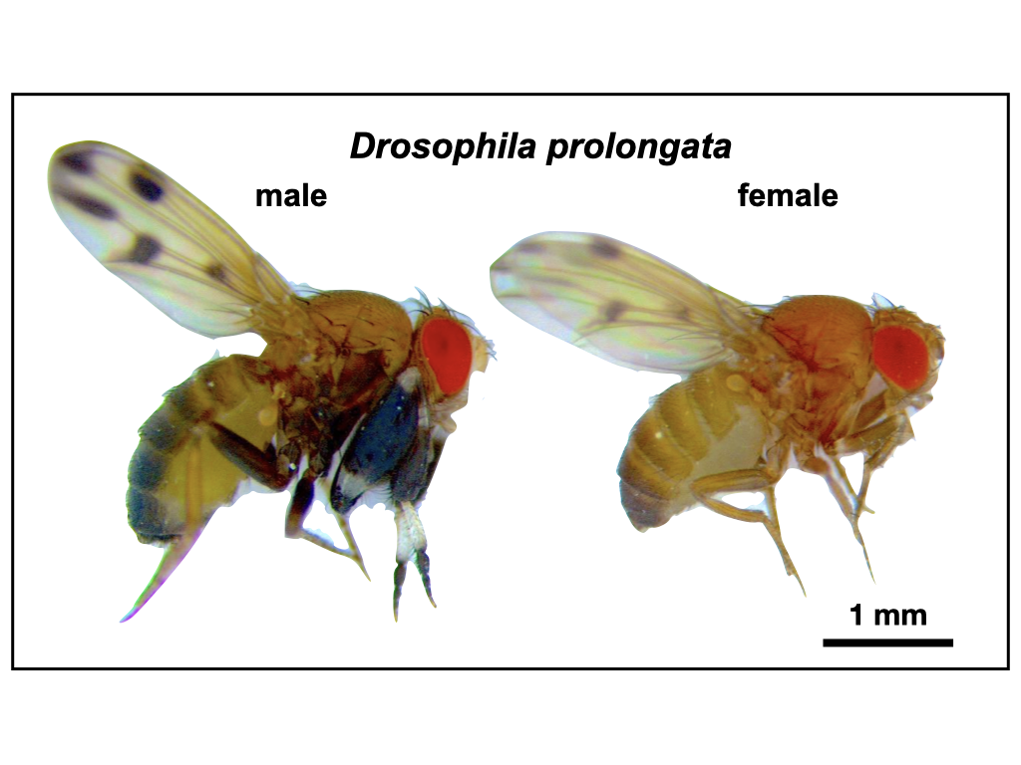

Figure 1. Drosophila prolongata has a suite of recently evolved male-specific traits, ideal for studying the evolution of sexual dimorphism. Most noticeable is the size and pigmentation banding of front legs in males. Other sexually dimorphic characteristics include wing spots, eye shape, pigmentation, and increased length of second and third legs.



Figure 2. Dovetail assembly process generates high contiguity assembly. Comparison between initial PacBio FALCON with Arrow polished assembly (“Input Assembly”) and final assembly generated by Dovetail HiC scaffolding method (“HiRise Assembly”), provided by Dovetail genomics. Each curve shows the fraction of the total length of the assembly in scaffolds of a given length or smaller. Scaffolds less than 1kb are excluded.

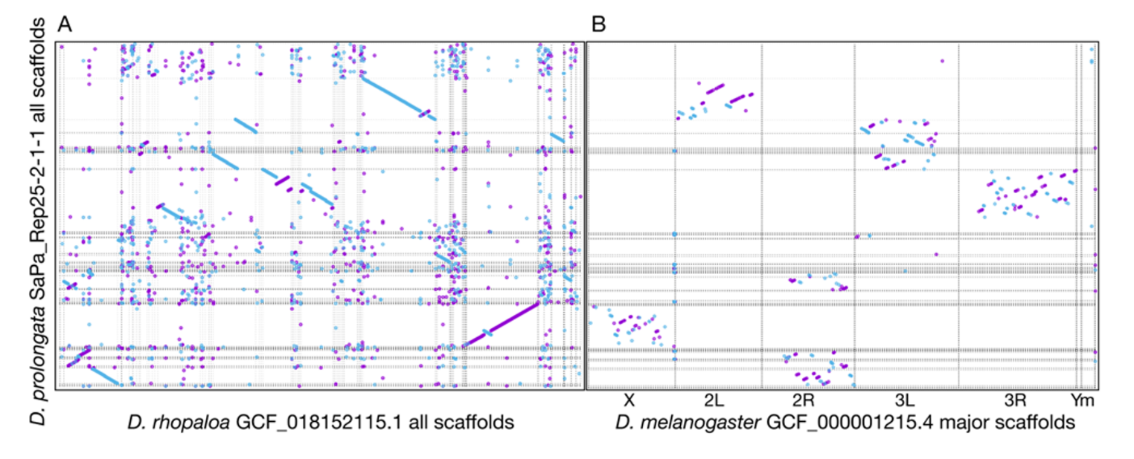

Figure 3. Whole genome alignments between all scaffolds of *D. prolongata* assembly and reference assemblies. (A) Alignment to *D. rhopaloa* based on minimum 1000bp matches, showing all reference scaffolds as ordered in assembly. (B) Alignment to major chromosome arms from *D. melanogast*er assembly, based on minimum 500bp matches. Forward matches are shown in purple, and reverse matches in blue.

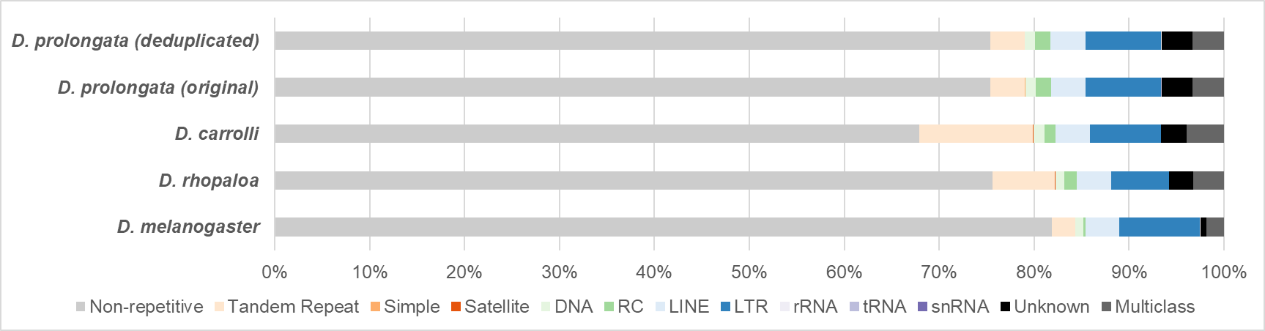

Figure 4. Genome-wide repeat content of *D. prolongata* (before and after de-duplication) and reference species group. Repeat contents are color coded as follows. Low-complexity regions (Tandem repeats, simple repeats, Satellite): orange palette, DNA transposons (DNA, RC): green palette, retrotransposons (LINE, LTR): blue palette, RNA: purple palette. Abbreviations for each repeat class are as follows. RC: Rolling Circle transposons, LINE: Long-Interspersed Nuclear Element, LTR: Long-Terminal-Repeats retrotransposon, snRNA: small-nuclear RNA, Unknown: unknown class of repeats/transposons, Multiclass: sequences belonging to more than one repeat class.

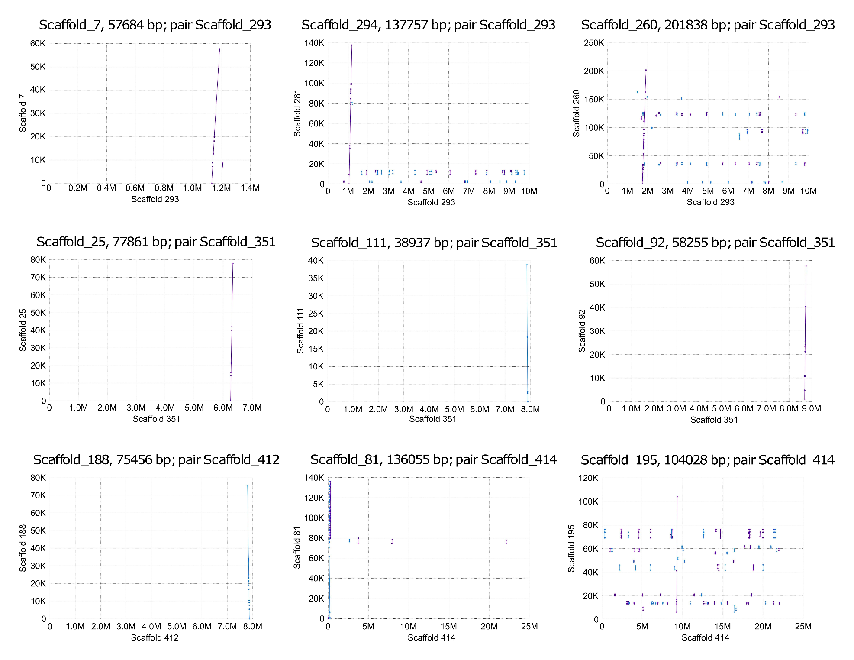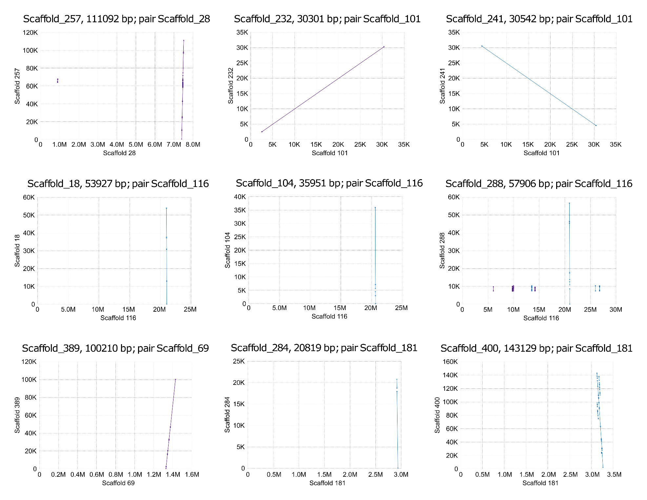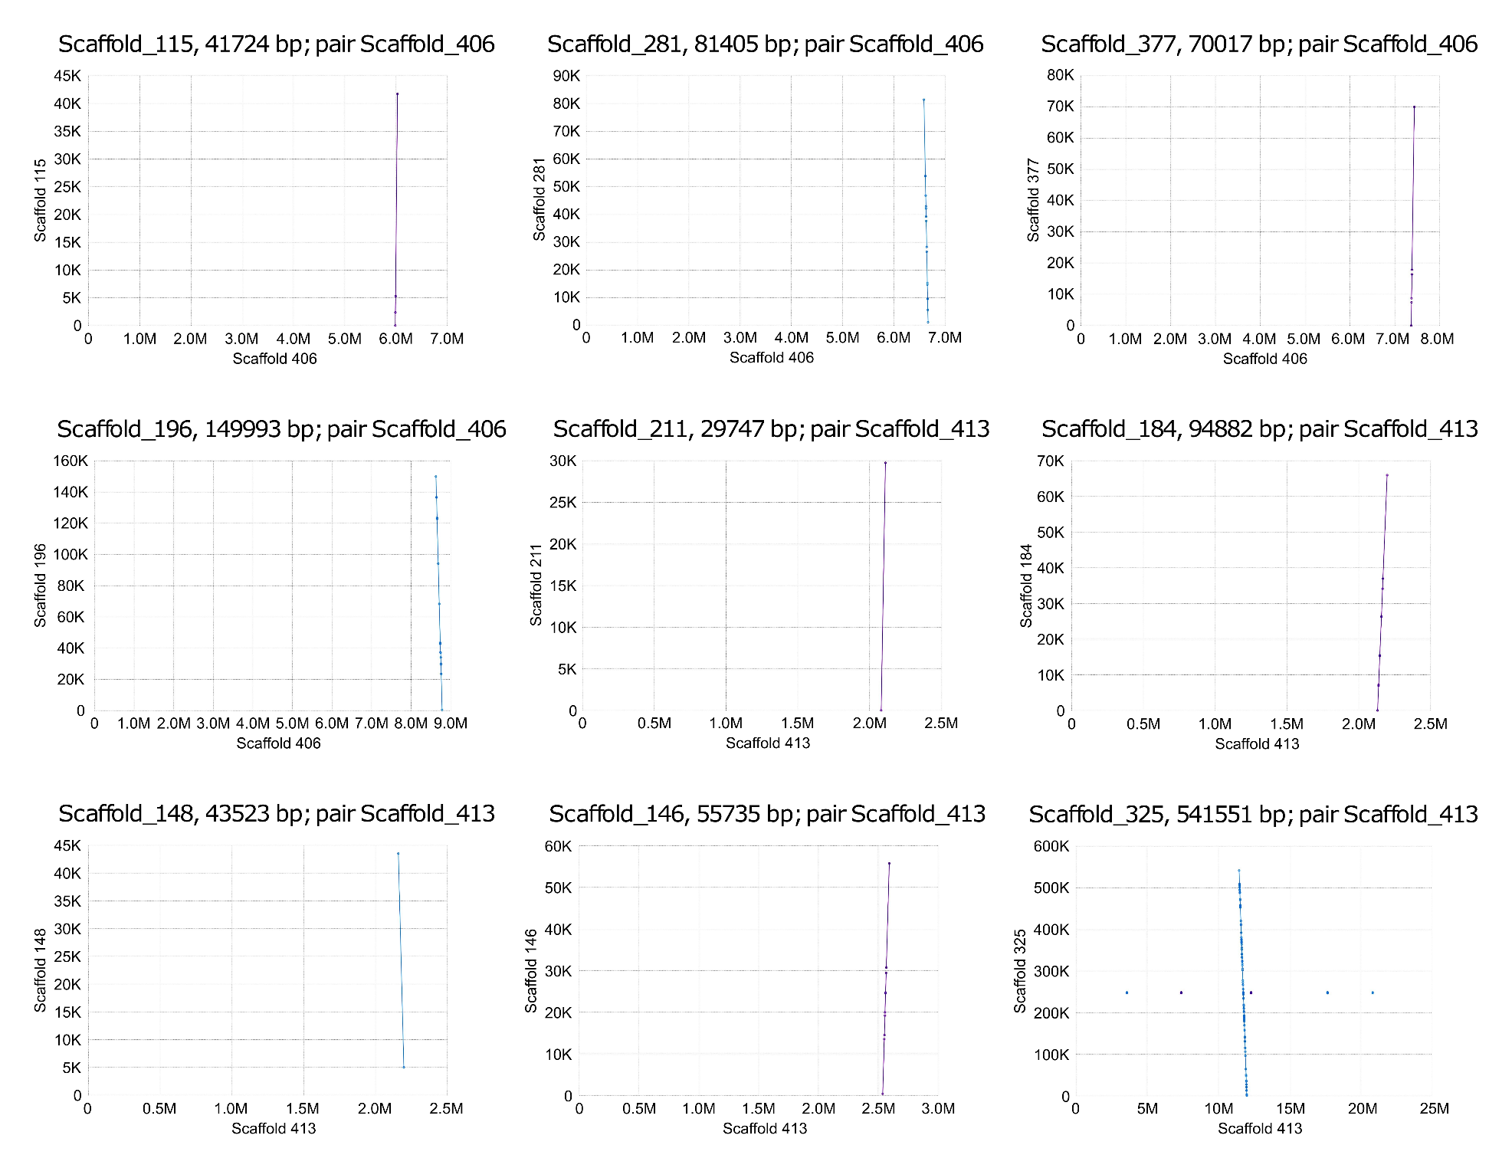

Figure S1. Pairwise MUMmer alignments between 27 duplicate scaffolds and sister scaffolds. Straight lines show alignment between duplicate scaffolds (y-axis) and sister scaffolds (x-axis), with alignment boundaries indicated by flanking points. Sense alignment between scaffolds is shown in red, and antisense alignment is in blue.

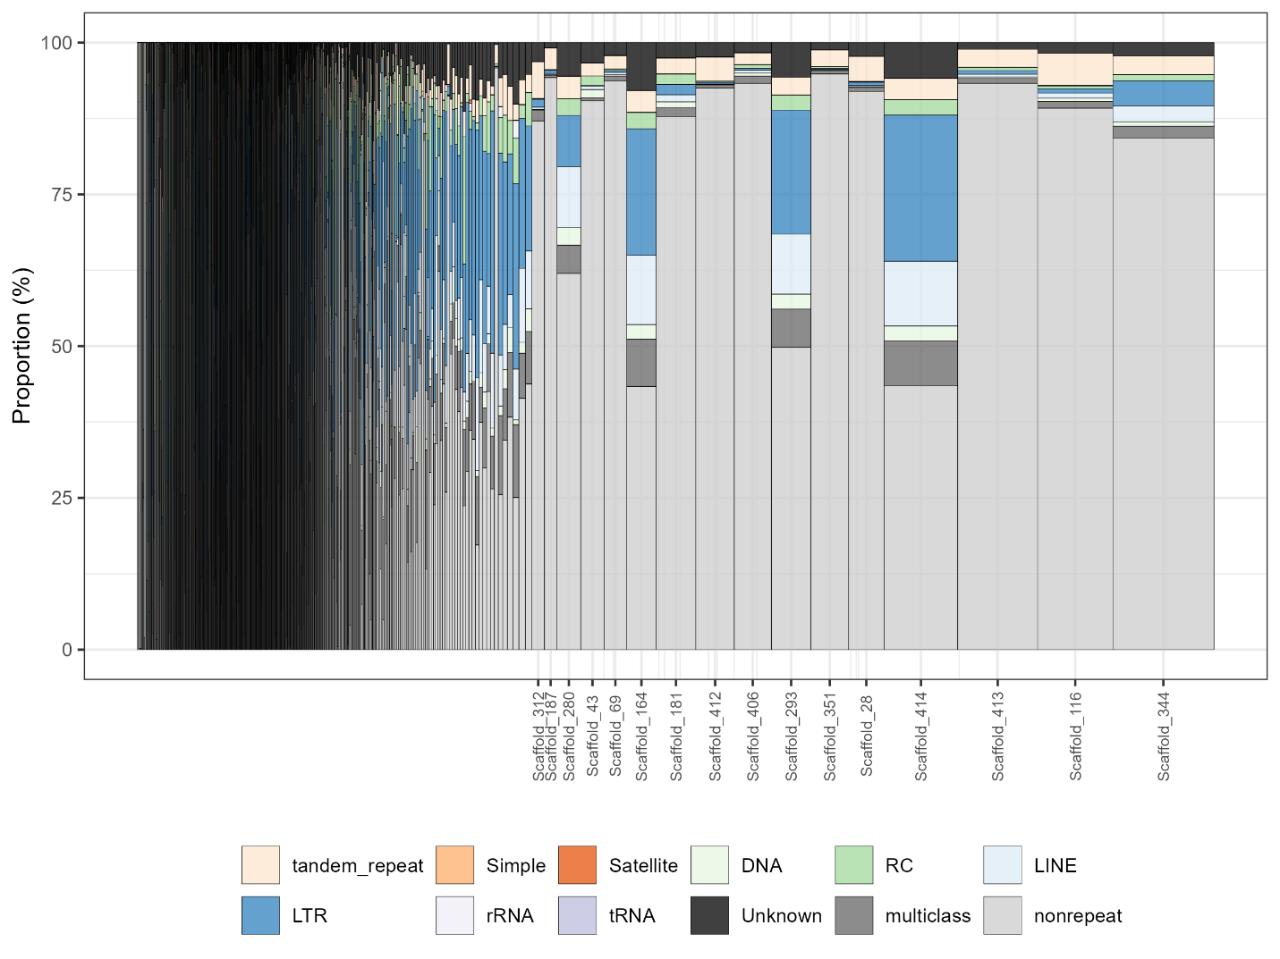

Figure S2. Stacked bar plots showing the distribution of repeat content by scaffolds in *D. prolongata* genome assembly (deduplicated). Widths of bars are proportional to the square root of scaffold/chromosome lengths. Scaffold names are displayed for those of length 1Mb or greater. Repeat contents are color coded as follows. Low-complexity region: orange palette, DNA transposon: green palette, retrotransposon: blue palette, RNA: purple palette. Abbreviations for each repeat class are as follows. RC: Rolling Circle transposons, LINE: Long-Interspersed Nuclear Element, LTR: Long-Terminal-Repeats retrotransposon, snRNA: small-nuclear RNA, Unknown: unknown class of repeats/transposons, multiclass: sequences belonging to more than one repeat class, nonrepeat: non-repetitive DNA sequence.

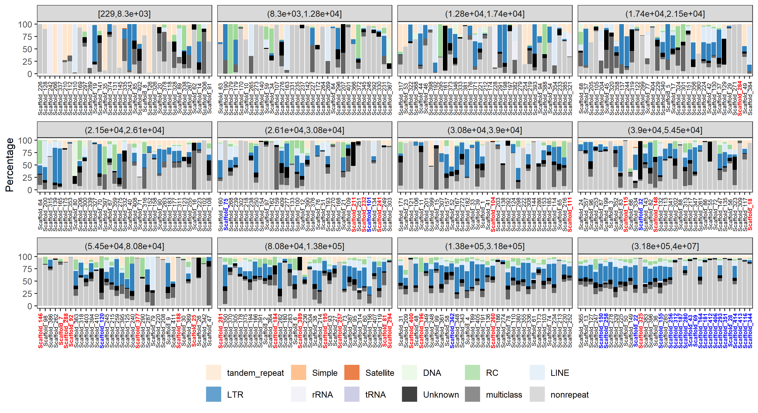

Figure S3. Stacked bar plots showing the distribution of repeat content by scaffolds (partitioned by scaffold length bins) in *D. prolongata* genome assembly. Scaffold names are ordered by their corresponding lengths. Repeat contents are color coded as Fig. S2, with the exception that removed scaffolds have names colored red, and scaffolds that are initially suggested as “duplicated” but not removed are colored in blue.

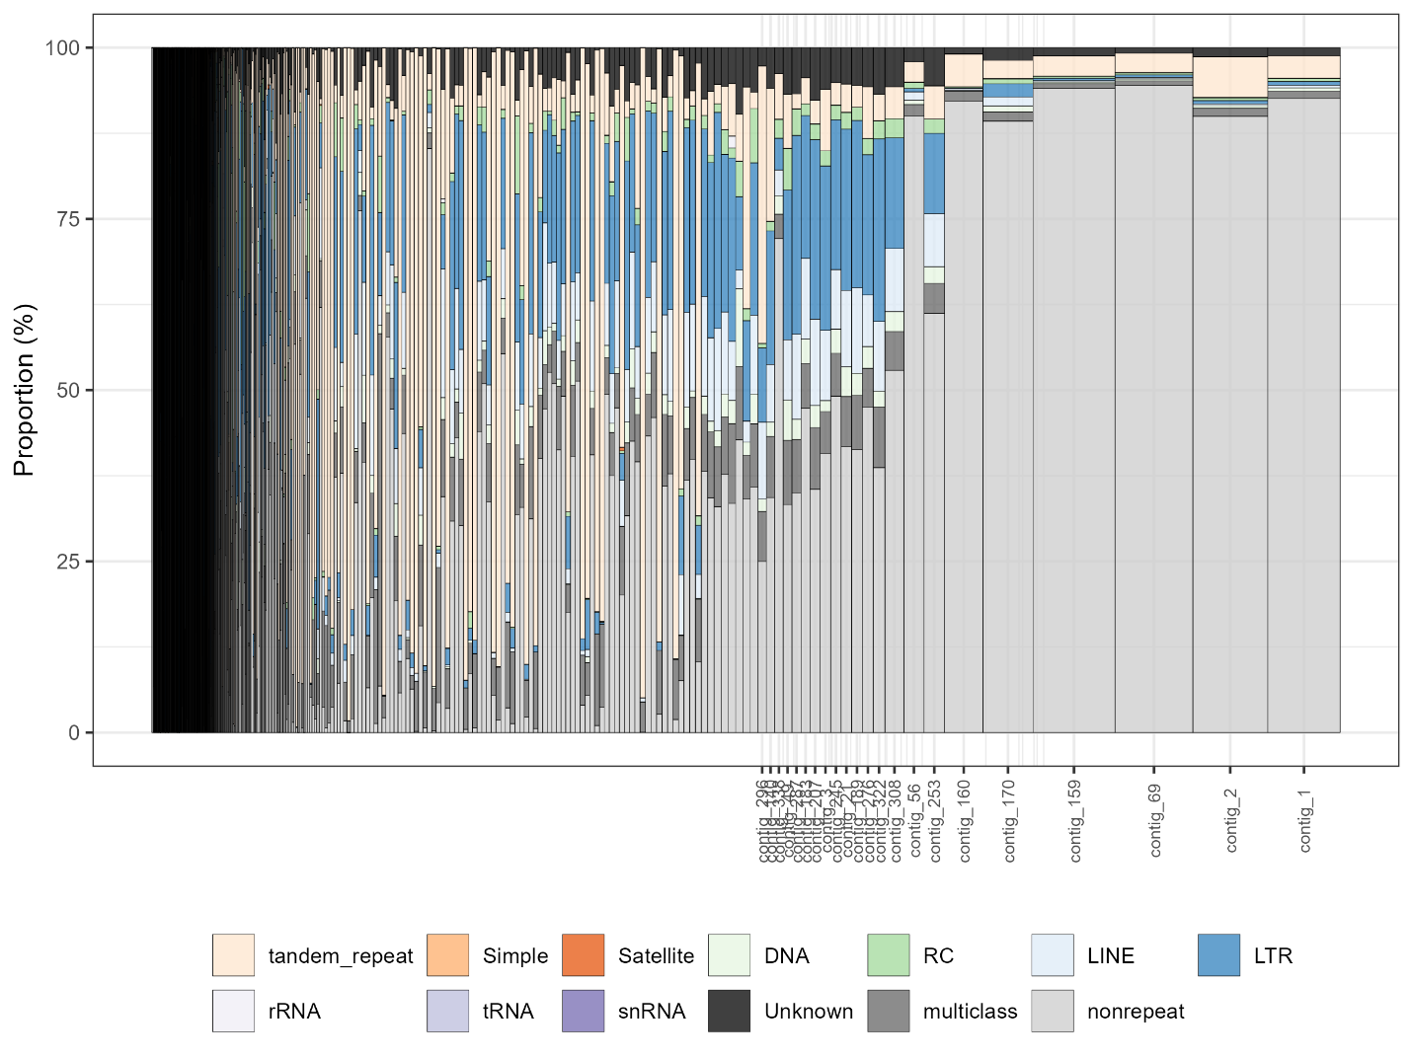

Figure S4. Stacked bar plots showing the distribution of repeat content by scaffolds in *D. carrolli* genome assembly. Widths of bars are proportional to the square root of scaffold/chromosome lengths. Repeat contents are color coded as Fig. S2.

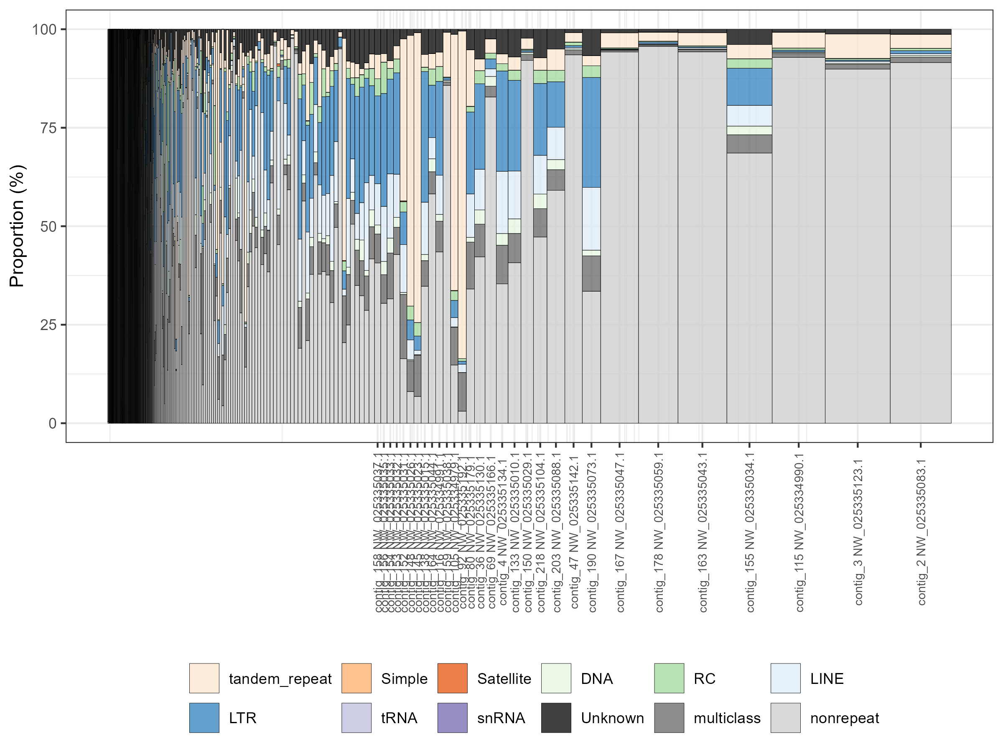

Figure S5. Stacked bar plots showing the distribution of repeat content by scaffolds in *D. rhopaloa* genome assembly (GCF_018152115.1_ASM1815211v1). Widths of bars are proportional to the square root of scaffold/chromosome lengths. Repeat contents are color coded as Fig. S2.

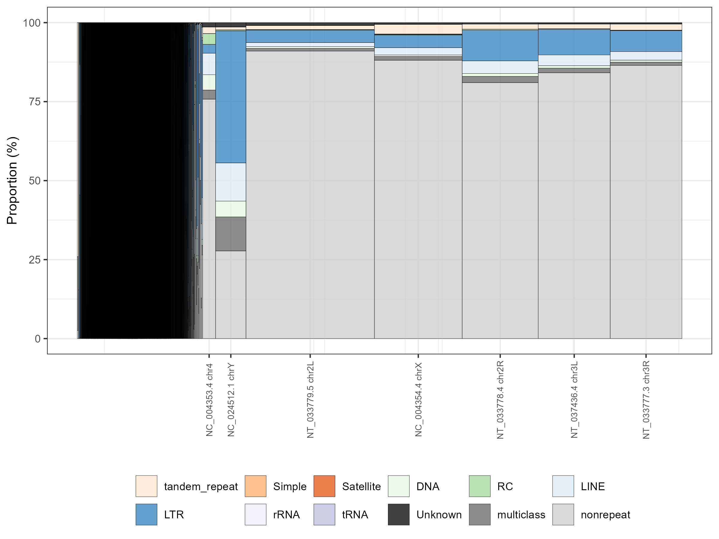

Figure S6. Stacked bar plots showing the distribution of repeat content by scaffolds in *D. melanogaster* genome assembly (GCF_000001215.4_Release_6_plus_ISO1). Widths of bars are proportional to the square root of scaffold/chromosome lengths. Repeat contents are color coded as Fig. S2.

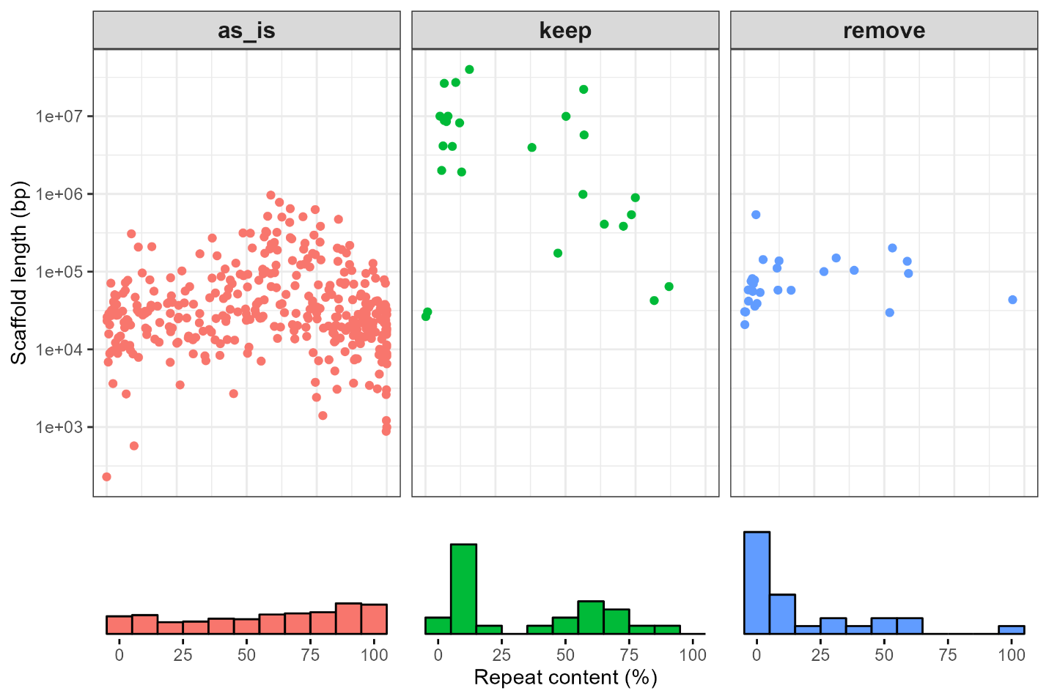

Figure S7. Scatter plots showing the distribution of repeat profiles by scaffolds under each category in the complete *D. prolongata* genome assembly. Frequency histograms of repeat content are displayed at the bottom. X-axis is the repeat content (%), and the y-axis is the corresponding scaffold length. Scaffolds with no BUSCO duplicates are colored in red (as_is), retained scaffolds with BUSCO duplicates in green (keep), and removed scaffolds with BUSCO duplicates in blue (remove).